Speaker Cup
Purpose
The purpose of this lab is to see how electromagnetism is used to create movement. Using only the necessary components of a speaker we will investigate how this technology was created out of knowledge of electromagnetism.

Pre Lab Questions
- Draw a speaker.

- How do you think a speaker works?

3. What do you feel when some one drives by blasting bass out of their car?

Application Activity
Hypothesis
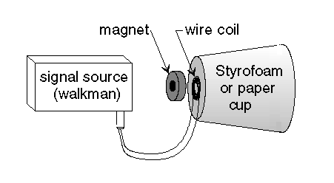
How do you think we can use the concept that a solenoid attracts magnets to make a vibrating membrane (speaker)?
M5.W5.D3  CW/HW #3 | Speakers  Electromagnetism | Name:  Date:  Period:

Procedure
- Gather materials.
- Tape the magnet speaker on the bottom of the cup.
- Create a solenoid.
- Tape the solenoid to the bottom of the cup.
- Prepare/strip the speaker cable.
- Connect the speaker cable to the solenoid.
- Plug and play!

Observation/Results
Record your observation and results below. This should include independent variables and their respective dependent variables. Good results are meticulous and clear be sure to have illustrations and quantifiable independent variables (numbers).

Post Lab Questions
- What is the minimum equipment you need to make a speaker?

- Describe how alternating current results in music?

- Draw and label a diagram of your speaker.

- Does it matter where the magnet goes? Tinker!

5. a. What is one upgrade you can make to your speaker to make it sound better?

- Draw a speaker with accenting this upgrade.

c. Did the speaker sound better with your upgrade?

Conclusion
Explain to a middle schooler how a speaker works. Include the pathway starting from a headphone wire to the vibrations in the speaker. Draw diagrams and a comic to explain.

